**School Student Performance Analysis: A Tableau Project Report**

* **by Kowsik.S**

**Table of Contents**

1. Introduction

2. Executive Summary

3. Data Fields

3.1 Dimensions

3.2 Measures

4. Calculated Fields

4.1 Performance Description

4.2 Result

5. Worksheets

5.1 AVG Percent on Class (%)

5.2 Region vs Grade

5.3 AVG TOTAL vs Performance

5.4 Bottom 10 Performer

5.5 Average Mark on Grade Distribution

5.6 Top 10 Performer

5.7 Term vs Class

5.8 Region-wise Count & Avg Marks

5.9 AVG Subject Marks vs Regions

6. Dashboards

6.1 Dashboard 1: Term vs Class Dashboard

6.2 Dashboard 2: Highlight Region Dashboard

6.3 Dashboard 3: Top and Bottom Dashboard

7. Conclusion

**1. Introduction**

This report documents the Tableau project, which analyzes the academic performance of students across various regions, classes, and exam types. The project leverages a dataset named "School Performance" to create insightful visualizations through worksheets and dashboards. The report details the data fields, calculated fields, worksheets, dashboards, and applied filters used to derive meaningful insights into student performance metrics.

**2. Executive Summary**

The "School Student Performance" project provides a comprehensive analysis of student academic performance across multiple dimensions, including region, class, exam type, and subject-wise marks. Key findings include:

- Students in the Seventh class achieved the highest average percentage (64.46%), while the Ninth class had the lowest (39.25%).

- The top performer, PRATHESHVARAN A, scored 90.90%, while the lowest performer, AKASH S, scored 10.40%.

- Region-wise analysis shows variations in subject performance, with Thanjavur consistently scoring higher across subjects.

This project aims to assist educators in identifying performance trends and areas for improvement.

**3. Data Fields**

The dataset "School Performance" contains the following fields, which are categorized into dimensions and measures:

**3.1 Dimensions**

- Region: The geographical region of the school (e.g., Chennai, Coimbatore, Dindigul).

- Class: The class of the student (e.g., Sixth, Seventh, Eighth, Ninth).

- Section: The section within the class (e.g., A, A1).

- Exam Type: The type of examination (e.g., Quarterly Exam, Half Yearly Exam, Annual Exam).

- Academic Year: The academic year of the data.

- Grade: The grade achieved by the student (e.g., A, B, C, D, E).

**3.2 Measures**

- Language: Language subject performance.

- English: English subject performance.

- Maths: Marks obtained in Mathematics.

- Science: Marks obtained in Science.

- Social: Marks obtained in Social Studies.

- Total Marks: Total marks obtained by the student.

- Percentage: Percentage score of the student (calculated as a measure).

Figure 1: Data Fields in the School Performance Dataset

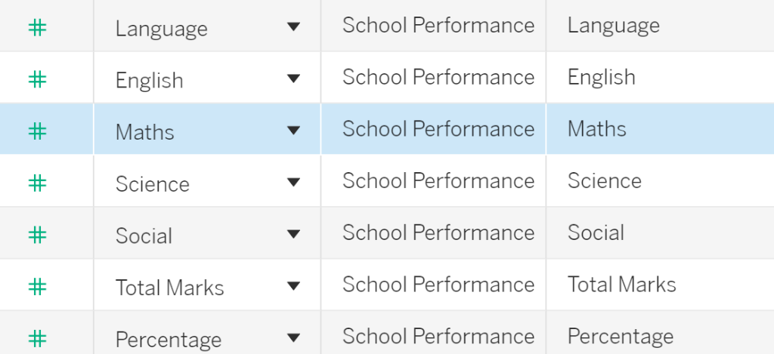

**4. Calculated Fields**

The project includes two calculated fields to enhance analysis:

**4.1 Performance Description**

This calculated field categorizes student performance into descriptive grades based on their percentage score.

Figure 2: Calculated Field: Perf_Description

**4.2 Result**

This calculated field determines a pass/fail status based on the percentage score.

Figure 3: Calculated Field: Result

**5. Worksheets**

The project includes several worksheets that visualize different aspects of student performance.

**5.1 AVG Percent on Class (%)**

Type: Highlight Table (Heatmap)

Description: Displays the average percentage for different classes (Sixth, Seventh, Eighth, Ninth).

Details:

- Rows: Class

- Columns: None

- Marks:

- Color: AVG(Percentage) (green to red gradient)

- Text: AVG(Percentage)

- Data:

- Sixth: 59.50% (green)

- Seventh: 64.46% (green)

- Eighth: 51.10% (yellow)

- Ninth: 39.25% (red)

- Filters: Class, Region, Grade

Figure 4: Worksheet: AVG Percent on Class (%)

**5.2 Region vs Grade**

Type: Scatter Plot

Description: Shows the distribution of grades across different regions.

Details:

- Rows: AVG(Percentage)

- Columns: Region

- Marks:

- Color: Grade (A: blue, B: orange, C: red, D: cyan, E: green)

- Shape: Grade

- Filters: Grade, Region, Class

Figure 5: Worksheet: Region vs Grade

**5.3 AVG TOTAL vs Performance**

Type: Histogram

Description: Displays the average total marks and count of students for each performance category.

Details:

- Rows: AVG(Total_Marks)

- Columns: Performance Description

- Marks:

- Color: Performance Description

- Text: CNTD(NAME)

- Data:

- Outstanding: 4 students

- Excellent: 9 students

- Distinction: 11 students

- Very Good: 14 students

- Good: 41 students

- Average: 55 students

- Satisfactory: 37 students

- Re-Appear: 49 students

- Filters: Perf_Description, Region, Class, Exam Type, Grade

Figure 6: Worksheet: AVG TOTAL vs Performance

**5.4 Bottom 10 Performer**

Type: Horizontal Bar Chart

Description: Lists the bottom 10 performers based on their average percentage.

Details:

- Rows: Name

- Columns: AVG(Percentage)

- Marks:

- Color: AVG(Percentage) (light to dark orange)

- Text: AVG(Percentage)

- Data:

- GOKULAKRISHNAN S: 14.600

- JEEVANANDAM C: 13.800

- DHARSAN G: 13.200

- AJAY P: 13.200

- SANTHOSH N: 13.000

- VIMEL VEL T: 12.800

- SANTHOSH K: 12.800

- LOGESHWARAN CS: 10.800

- RAKSHAN C: 10.600

- AKASH S: 10.400

- Filters: Name, Region, AVG(Percentage), Exam Type, Class

Figure 7: Worksheet: Bottom 10 Performer

**5.5 Average Mark on Grade Distribution**

Type: Histogram

Description: Shows the average total marks for each grade.

Details:

- Rows: AVG(Total_Marks)

- Columns: Grade

- Marks:

- Color: Grade

- Text: AVG(Total_Marks)

- Data:

- A: 458.4

- B: 421.0

- C: 372.7

- D: 325.4

- E: 220.0

- Filters: Grade, Region, Class, Exam Type

Figure 8: Worksheet: Average Mark on Grade Distribution

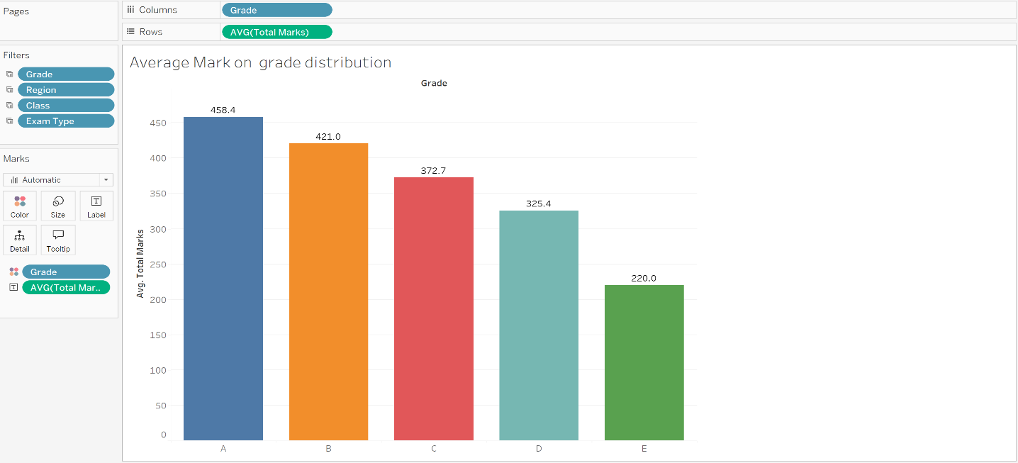

**5.6 Top 10 Performer**

Type: Horizontal Bar Chart

Description: Lists the top 10 performers based on their average percentage.

Details:

- Rows: Name

- Columns: AVG(Percentage)

- Marks:

- Color: AVG(Percentage) (light to dark blue)

- Text: AVG(Percentage)

- Data:

- PRATHESHVARAN A: 90.90

- APARNA S: 89.80

- MAYMOZHIKANNAN P: 87.80

- DHARSHAN K: 85.40

- DEVADHARSHAN P: 84.30

- JAYANDHAN BK: 83.80

- VISHNU SANGEERTH VK: 83.60

- KARTHIKEYAN J: 79.60

- S.PRAVEEN KUMAR: 79.00

- SANJAY V: 78.40

- Filters: Name, Region, AVG(Percentage), Exam Type, Class

Figure 9: Worksheet: Top 10 Performer

**5.7 Term vs Class**

Type: Sankey Diagram

Description: Visualizes the relationship between Exam Type, Class, and Section.

Details:

- Dimensions:

- Exam Type (Quarterly Exam, Half Yearly Exam, Annual Exam)

- Class (Sixth, Seventh, Eighth, Ninth)

- Section (A, A1)

- Marks:

- Color: Automatically assigned

- Link: Shows flow between categories

- Filters: Exam Type, Section, AVG(Percentage), AVG(Total_Marks)

Figure 10: Worksheet: Term vs Class

**5.8 Region-wise Count & Avg Marks**

Type: Map

Description: Displays a geographical map of regions with student count and average marks.

Details:

- Marks:

- Color: Region

- Size: CNTD(NAME)

- Label: Region names

- Filters: Region, Exam Type, Grade, Class

Figure 11: Worksheet: Region-wise Count & Avg Marks

**5.9 AVG Subject Marks vs Regions**

Type: Highlight Table (Heatmap)

Description: Compares average subject marks across regions.

Details:

- Rows: Measure Names (Language, English, Maths, Science, Social)

- Columns: Region

- Marks:

- Color: Measure Values (green to red gradient)

- Text: Measure Values

- Filters: Region, Grade, Exam Type, Class

Figure 12: Worksheet: AVG Subject Marks vs Regions

**6. Dashboards**

The project includes two dashboards that consolidate the worksheets for comprehensive analysis.

**6.1 Dashboard 1: Term vs Class Dashboard**

Description: This dashboard provides an overview of student performance across classes, exam types, and sections, alongside performance metrics.

Components:

- Term vs Class: Sankey diagram showing the relationship between Exam Type, Class, and Section.

- AVG Percent on Class (%): Heatmap displaying average percentages for each class.

- AVG TOTAL vs Performance: Histogram showing average total marks and student counts by performance category.

- Average Mark on Grade Distribution: Histogram showing average total marks by grade.

Filters:

- Region

- Exam Type

- Class

Figure 13: Dashboard 1: Term vs Class Dashboard

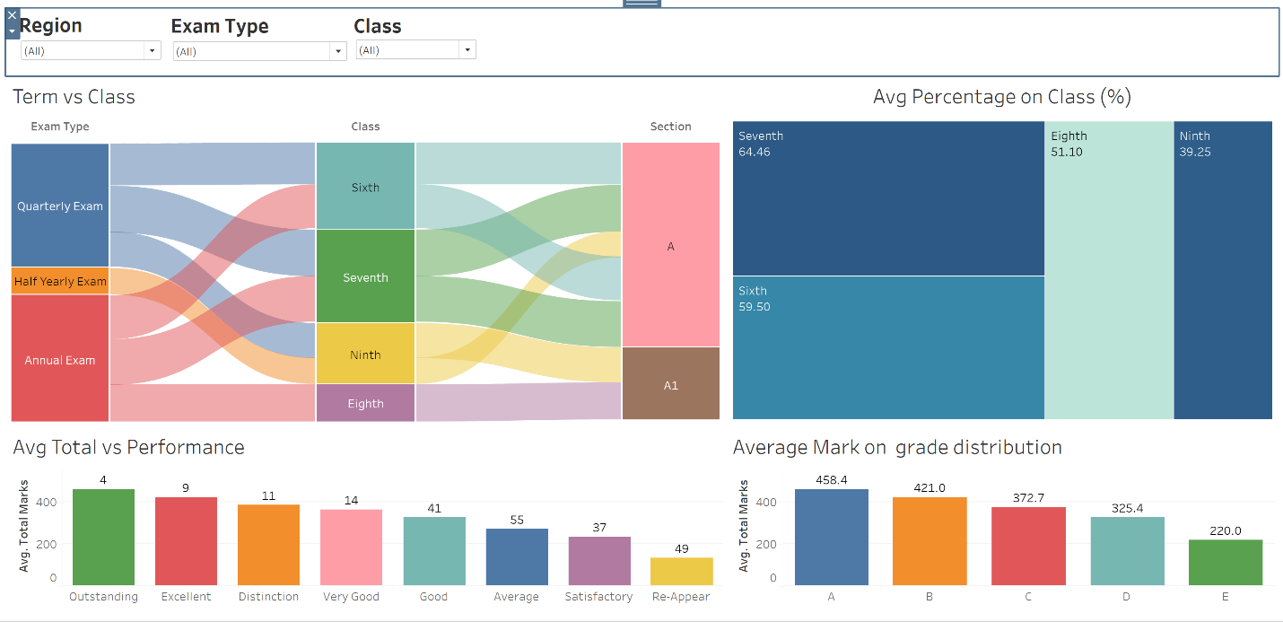

**6.2 Dashboard 2: Highlight Region Dashboard**

Description: This dashboard highlights regional performance, subject-wise marks, and top/bottom performers.

Components:

- AVG Subject Marks vs Regions: Heatmap comparing average subject marks across regions.

- Region-wise Count & Avg Marks: Map showing student distribution and average marks by region.

- Region vs Grade: Scatter plot showing grade distribution across regions.

- Top 10 Performer: Bar chart listing the top 10 performers by average percentage.

- Bottom 10 Performer: Bar chart listing the bottom 10 performers by average percentage.

Filters:

- Region

- Grade

- Class

Figure 14: Dashboard 2: Highlight Region Dashboard

**6.3 Dashboard 3: Top and Bottom Dashboard**

Description: This dashboard highlights top/bottom performers.

Components:

- Top 10 Performer: Bar chart listing the top 10 performers by average percentage.

- Bottom 10 Performer: Bar chart listing the bottom 10 performers by average percentage.

**7. Conclusion**

This project provides a detailed analysis of student performance across various dimensions such as region, class, and exam type. The visualizations, including heatmaps, scatter plots, histograms, bar charts, Sankey diagrams, and maps, offer insights into grade distributions, subject-wise performance, and individual student rankings. The dashboards consolidate these insights, allowing stakeholders to filter data by region, grade, and class to identify trends and areas for improvement. This project effectively leverages Tableau's capabilities to support data-driven decision-making in educational contexts.